Lab task(EXAM)

1. Show all data associated in salgrade table

select \*from salgrade;

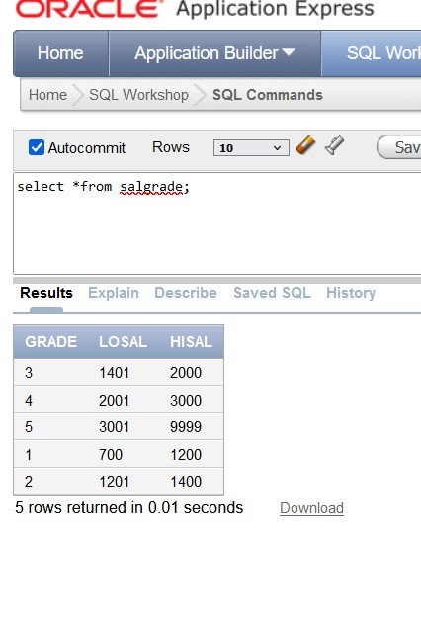

1. select deptno from dept;

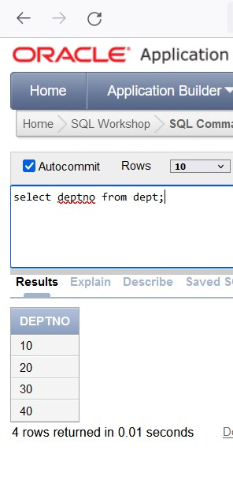

1. select ename,sal,(sal+sal\*0.05)"5% INCREMENT"from emp;

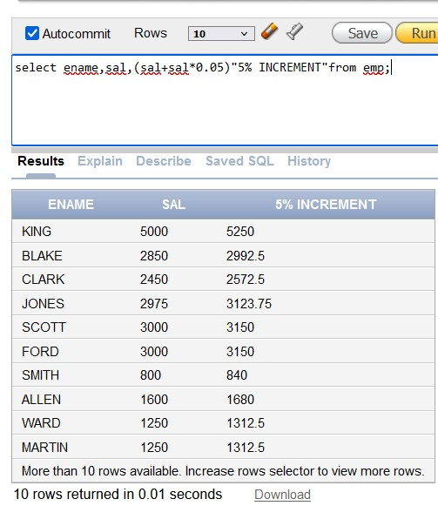

1. select ename, sal\*0.05 AS "NEW SALARY" from emp;

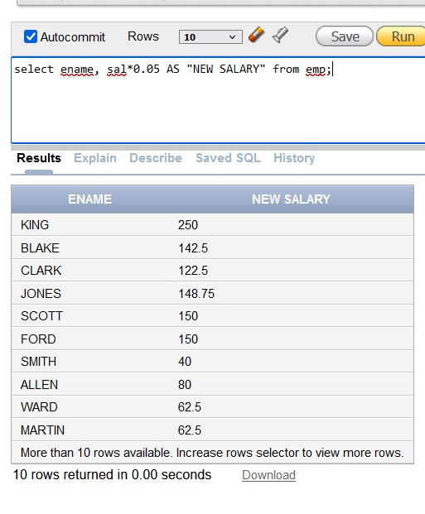

1. select \* from emp where ename='BLAKE';

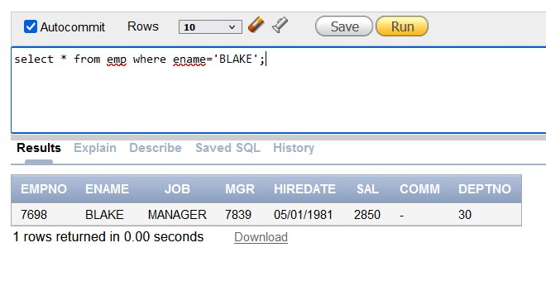

7.describe emp;

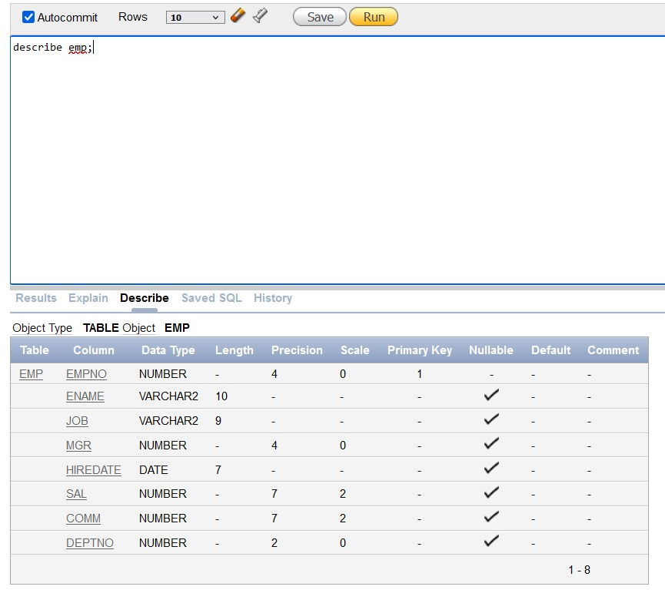

8.select distinct job from emp;

